**Introduction**

First of all I want to give the readers excuses for my little bad english. Second to said that this Tutorial was made on a Raspberry Pi model B, using Python 3.5.3 (default, Jan 19 2017, 14:11:04) [GGC 6.3.0 20170124] on Linux and following the Book Guide from TIM COX Raspberry pi Cookbook for python programmers, **Chapter 7.**

First thing we are going to do is to do is to learn a little bit of I2C communication on the RPi which is the way we used to communicate with our SUNFOUNDER AD/DA converter module PCF8591. Second, we will create our own script that allow us to communicate with the ADC module and finally to gather data through the analog inputs and write it in a logfile to then plot the data.

The whole repository it is available on my github account (<https://github.com/LatinAmericanProgramer/Python-Analog-to-Digital-Converter-with-PCF8591>) . For more Information feel free to contact me with this information:

Biomedical Engineering Student

Member of Biomedical Engineering Research Group

Autonomous University of the West (Universidad Autónoma de Occidente)

Cali, Colombia

Contact: + 57 (310) – 434 8314

ing.kevin@hotmail.com, kevin.machado@uao.edu.co

Let’s start.

**Enabling Raspberry Pi & I2C**

La manera más común de conectar diferentes dispositivos con una raspberry pi es a través del conocido bus I2C (I-Squared-C). Uno de los dispositivos que podemos conectar es el modulo conversor analogico digital PCF8591. This is an 8-bit ADC which allow us to convert analog signals into 2^8 possible values, this means from 0 to 255.

First, we need to enable the I2C bus in our Raspberry Pi because this feature is normally unable. To do this, we need to ensure that the I2c feature is not (or commented it with ‘#’) into the blacklist file named “**raspi-blacklist.conf**” as follow:

Open the terminal and to get into the “**raspi-blacklist.conf**” file type:

**sudo nano/etc/modprobe.d/raspi-blacklist.conf**

Then, we need to erase or comment (with ‘#’ at the start of the line) all the features we want out of the blacklist file, for example:

**# blacklist i2c-bcm2708**

**# blacklist spi-bcm2708**

(Ctrl X) to exit

Next, we should make the I2C module to be loaded whenever we power up the Raspberry Pi, including the next line in the file “modules” as follow:  
  
First locate the file at the terminal, typing:  
**Sudo nano /etc/modules**

Then include:

**I2c-dev**

**I2c-bcm2708**  
Or  
**I2c-bcm2835** (depending on your Raspberry Pi model)

Next, we need to install some tools to use I2C devices directly from the command line, as follow:

**sudo apt-get update**

**sudo apt-get install i2c-tools**

Finally, reboot the Raspberry Pi to make the changes be applied.

**sudo reboot**

Or

**sudo shutdown -h now**

**Working with AD/DA converter PCF8591T - SUNFOUNDER MODULE**

This tutorial was made with the SUNFOUNDER module AD/DA converter PCF8591T same as the one on the next picture.

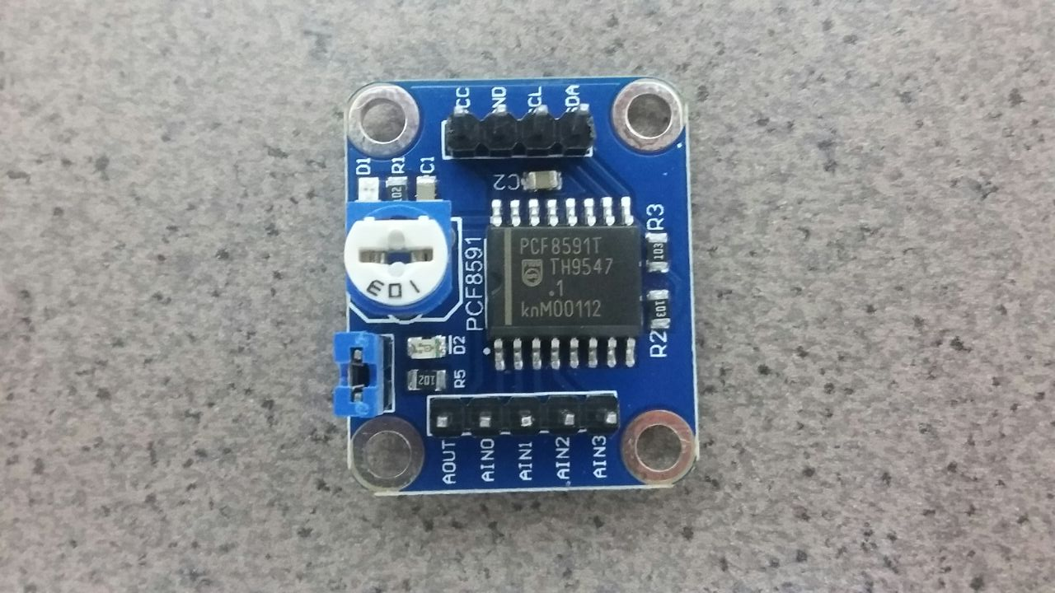

**AD/DA converter PCF8591T - SUNFOUNDER MODULE**

We need to connect this module to the Raspberry Pi as follow:

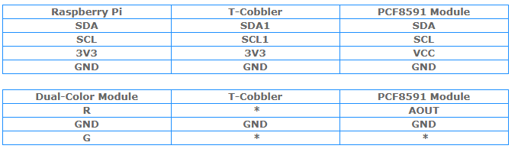

Image modified from sunfounder (ref: https://www.sunfounder.com/learn/sensor-kit-v2-0-for-raspberry-pi-b-plus/lesson-13-pcf8591-sensor-kit-v2-0-for-b-plus.html)

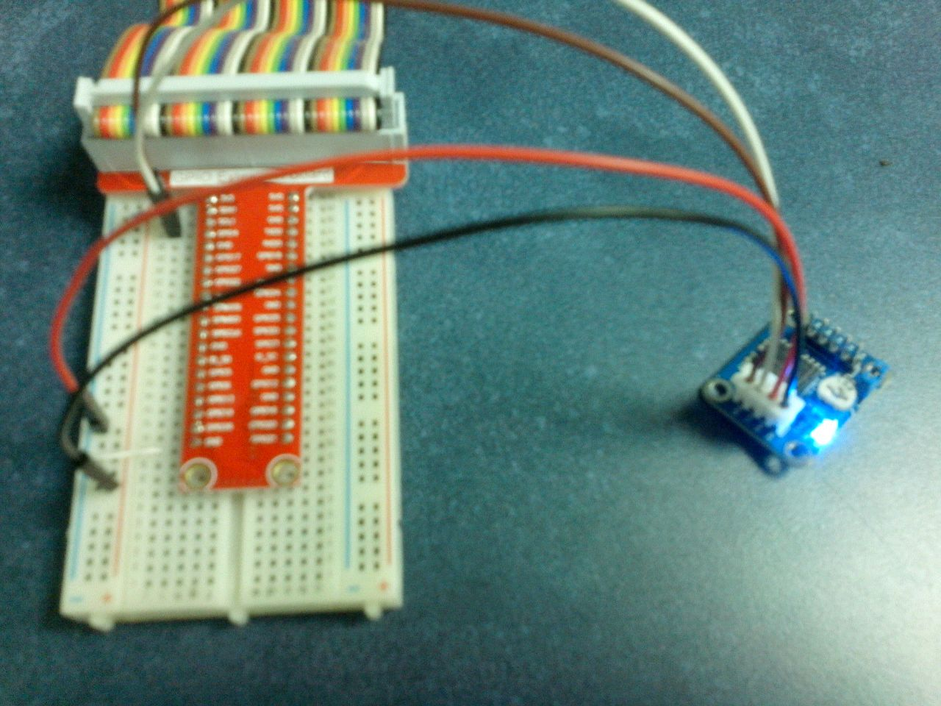

**AD/DA converter PCF8591T - Connection with Raspberry Pi**

Then, we can check if the PCF8581T is detected by the raspberry. To achieve this we can use the i2cdetect function at the terminal as follow:

**sudo i2cdetect -y 1 (bus # 1 in our case, “sudo i2cdetect -y 0” otherwise)**

We will watch the PCF8591 address (48) displayed as follow:

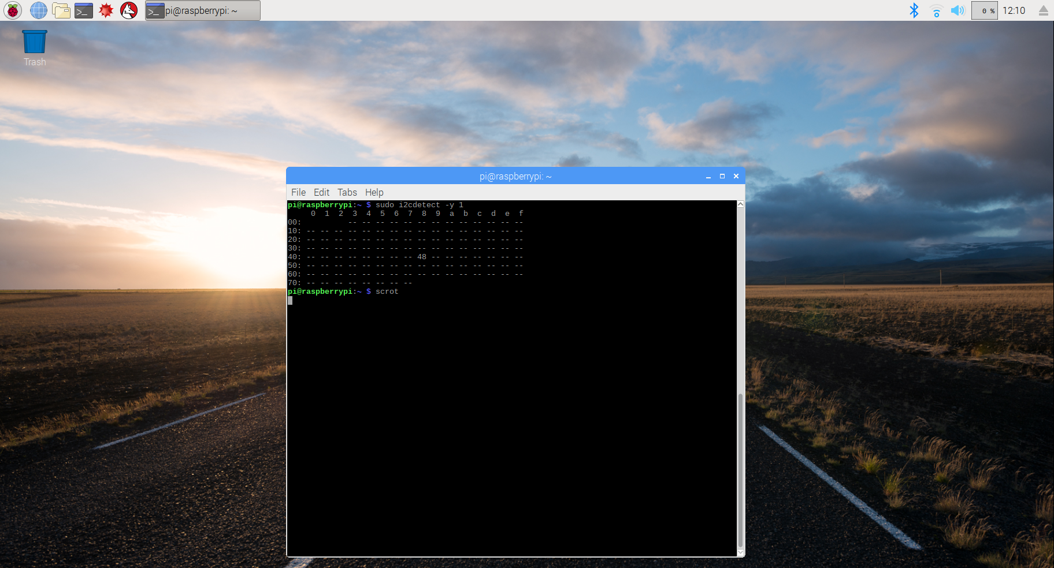

ScreenShot from the terminal

Now, finally we are ready to read or write to the PCF8591 registers, in order to make the device work as we needed it. Depending on the Raspberry Pi Board model, after to identify the bus (# 1 in our case) and the device address (0x48) we can use the function ‘**i2cget**’ to **read** from the device twice (twice to get the last value) as follow:

**sudo ic2get -y 1 0x48  
sudo ic2get -y 1 0x48**

For example, let’s said we want to read from channel one while this pin is connected to 0v, then we need to write to the control register 0x01 in the PCF8591 using the function ‘i2cset’ and read twice as follow:

**sudo ic2set -y 1 0x48 0x01  
sudo ic2get -y 1 0x48**

**sudo ic2get -y 1 0x48**

We will have as a result 0x00 as shown in left side of the next picture. Otherwise, if we connect the pin AIN1 to vcc, then we will have as a result 0xff or 255 in decimal (right side) .

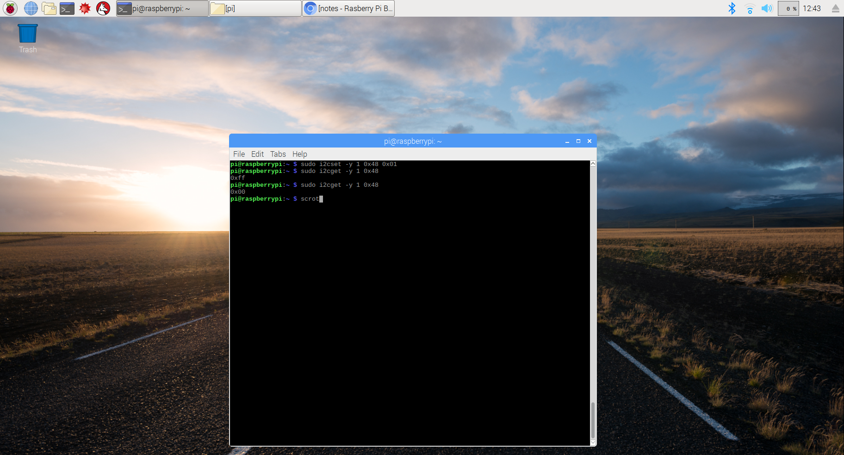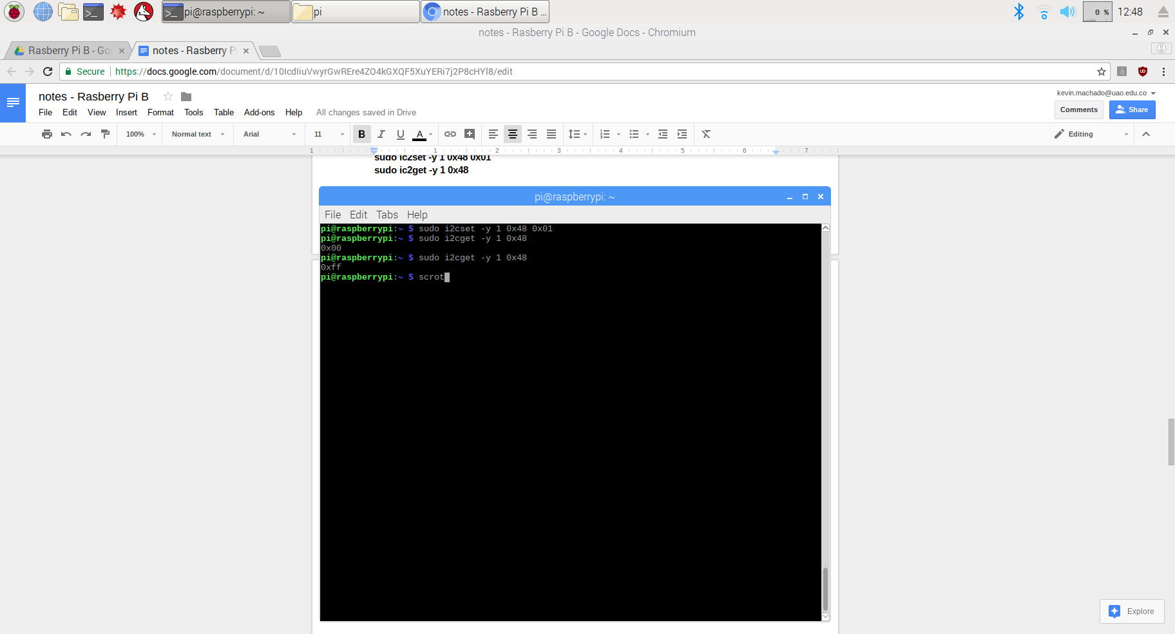

ScreenShot from the terminal

We can read from each of the four channels writing first and then reading from them by just specifying the channel 0x00, 0x01, 0x02 or 0x04.

Also, we can control the AOUT pin on and off typing:

**sudo i2cset -y 1 0x48 0x40 0xff #** *to turn it on*

or

**sudo i2cset -y 1 0x48 0x40 0x00 #** *to turn it off*

**Creating our library to read analog data from PCF8591**

According with the reference book (Raspberry pi Cookbook 1 for python programmers. Pag. 201), the I2CTools (used in the previous section) are very useful for debugging I2C devices on the command line, but they are not practical for use within Python, as they would be slow and

require significant overhead to use.

Instead of using those we will used some Python libraries to create our own module to quickly and easily obtain data from this ADC. To start with it we need to instal Gordon Henderson’s wiringPi2 (see http://wiringpi.com/ for more details). The easiest way is first installing the PIP package which is a manager for python that works in a similar way to apt-get and in which any package we would like to install will be automatically downloaded and installed from an online repository.

Install PIP as follow:

**sudo apt-get install python3-dev python3-pip**

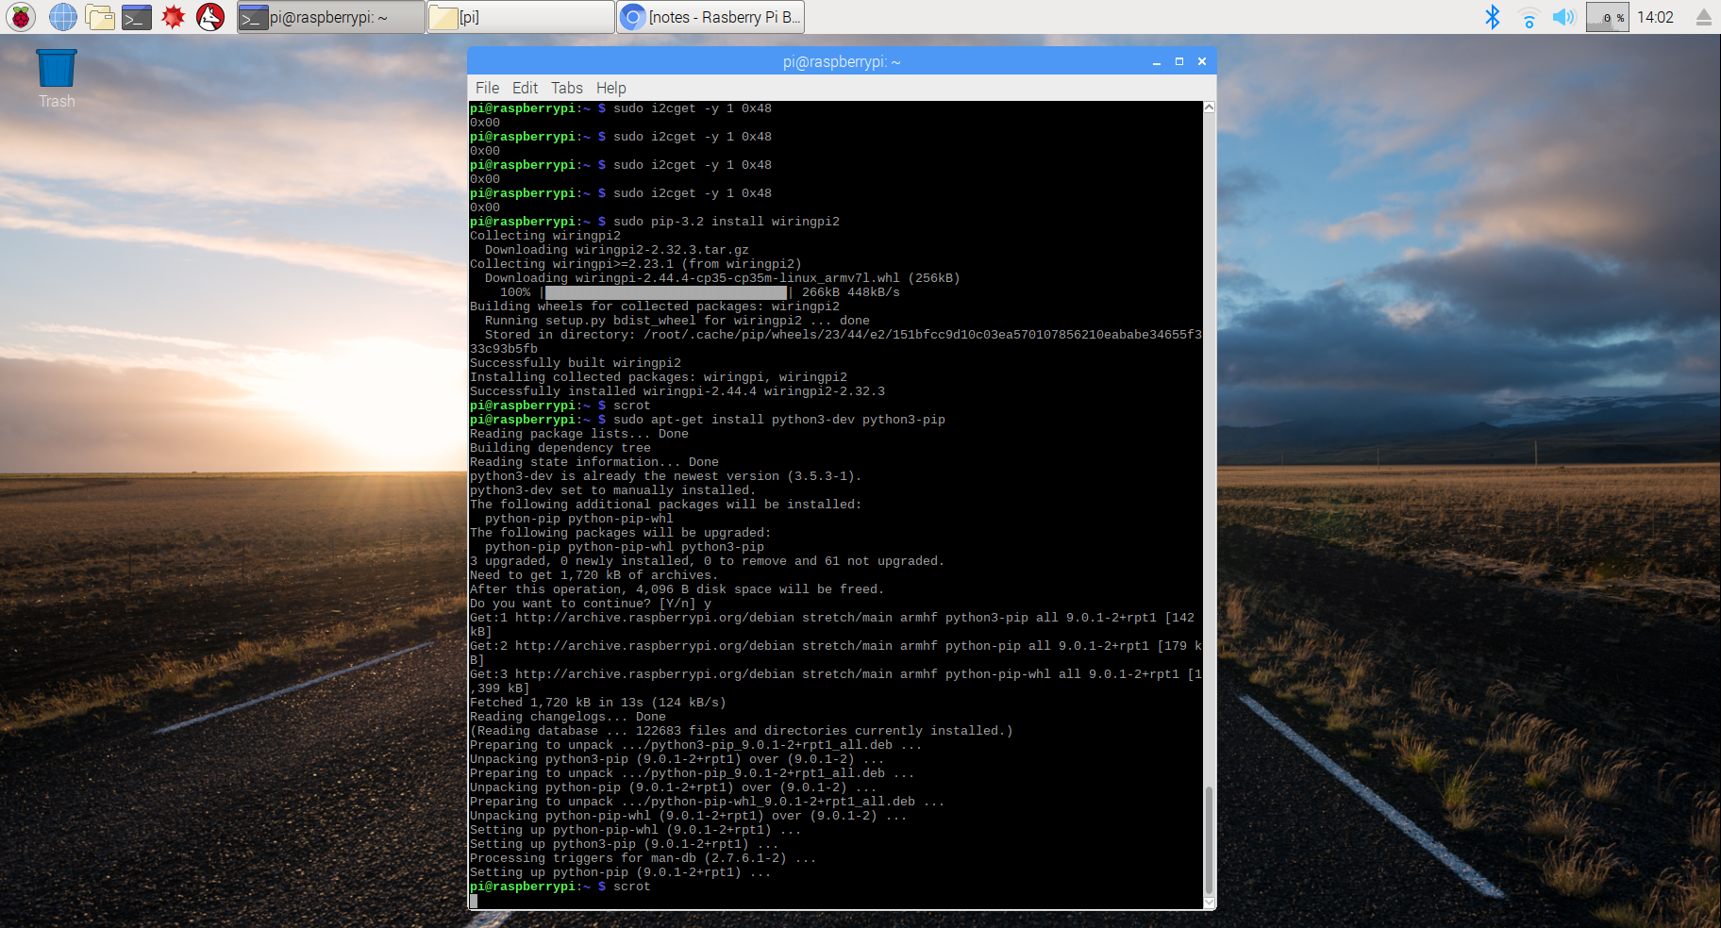

ScreenShot from the terminal

Then, install wiringPi2 as follow:

**sudo pip-3.2 install wiringpi2**

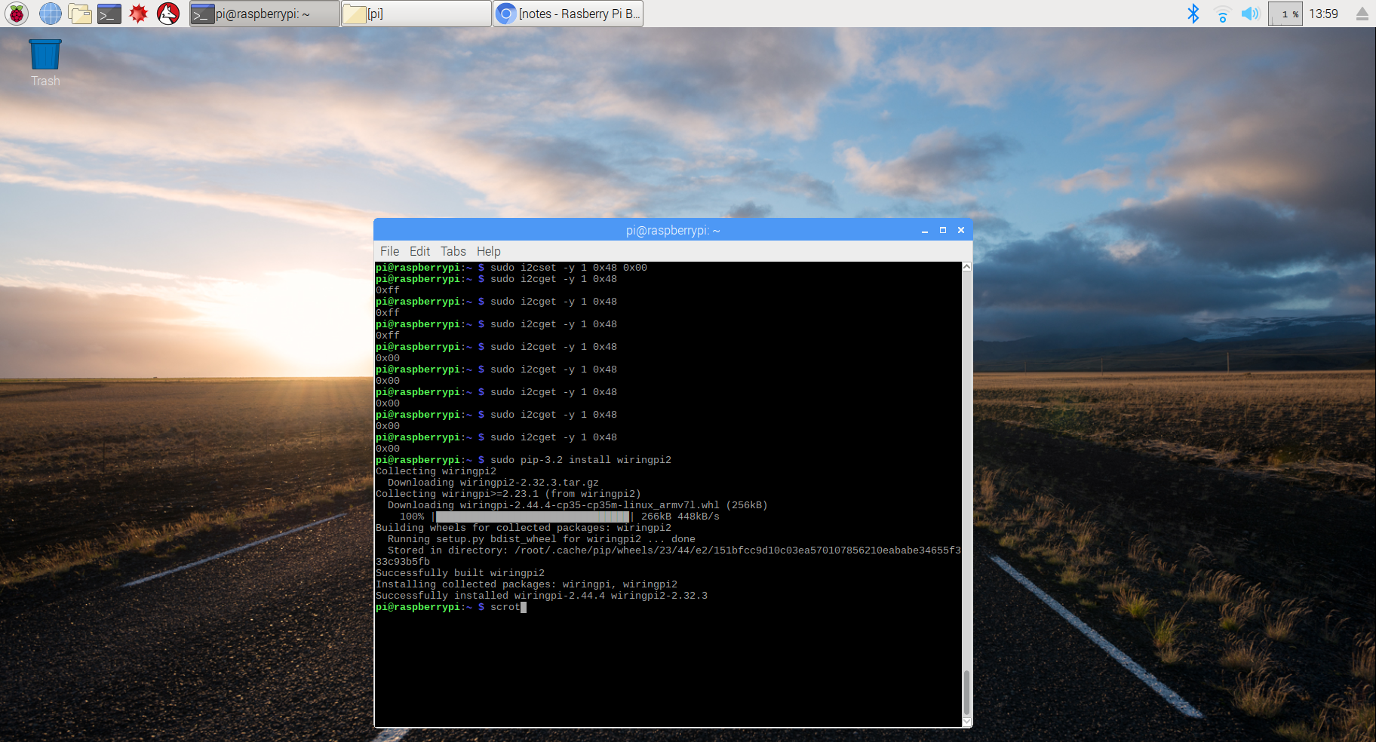

ScreenShot from the terminal - Successfully installed wiringPi2

After this installations we are available to write our own script to gather data. We can create a class to start the connection with the I2C bus using the function ‘**wiringpi2.I2C()**’ from wiringPi2 library and set up a generic I2C device with the chip's bus address using ‘**self.i2c.setup(0x48)**’. Also, we can perform a device read and configure the ADC to cycle through the channels (but instead of **i2cget** and **i2cset**, we use the wiringPi2 read and write functions of the I2C object). Once initialized, the device will be ready to read the analog signals on each of the channels.

The class will also have two member functions. The first function, **getName()**, returns a list of channel names (which we can use to correlate our data to its source) and the second function, **getNew()**, returns a new set of data from all the channels. The data is read from ADC using the **i2c.read()** function and, since we have already put it into cycle mode, each read will be from the next channel.

As we plan to reuse this class later on, we will use the if __name__ test to allow us to define some code to run when we execute the file directly. Within our main() function, we create ADC, which is an instance of our new device class. We can choose to select a non-default address if we need to; otherwise, the default address for the chip will be used. We use the **getName()** function to print out the names of the channels and then we can collect data from the ADC (using **getNew()**) and display them.

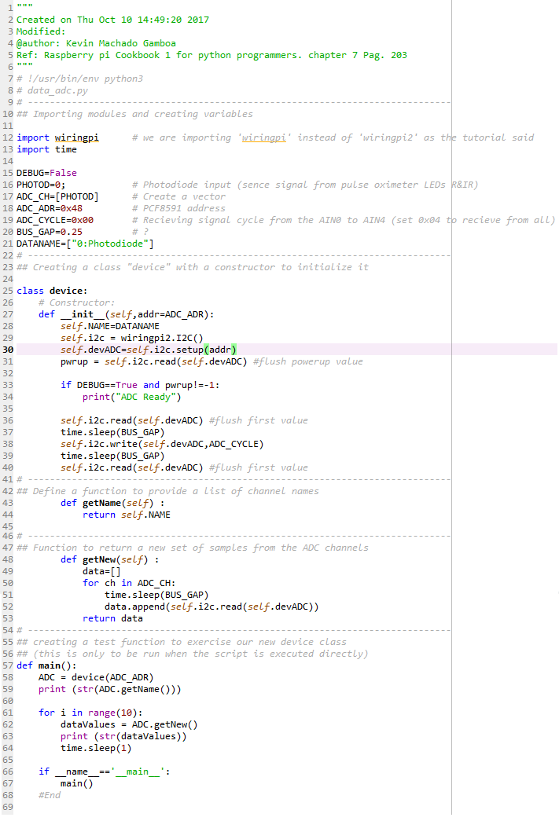

**Gathering analog data without Hardware**

The next script allow us to get information provide into the Raspberry pi without using external hardware. We will be available to get information like: CPU load, System Temperature, CPU Frequency, Random, RAM Total, RAM Used, RAM Free, Drive Used, Drive Free, and others.

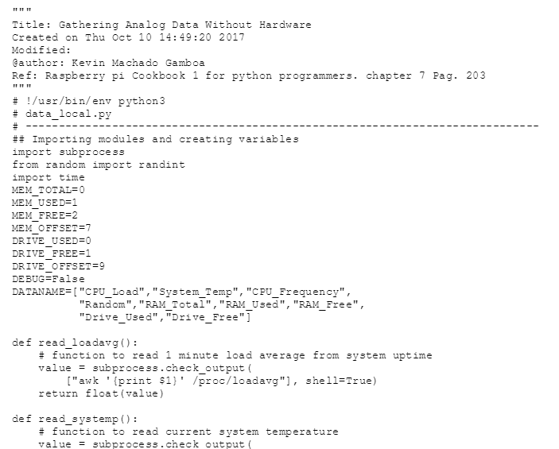

**Getting and Plotting Data**

The way in which we are going to proceed in order to capture and analyzed the data will using two scripts: one in which we will collect and write data into a logfile, and another one in which we will read the logfile created with the recorded data and then produce a graph. We will visualised recorded data using the function pyplot from the library called “matplotlib”. (ref: <http://matplotlib.org/users/pyplot_tutorial.html>.). We will call this first script as “**log_adc.py**” and the second one as “**log_graph.py**”

To achieve this, first we need to install numpy and matplotlib libraries, for example, following the next commands:

**sudo apt-get install tk-dev python3-tk libpng-dev**

**sudo pip-3.2 install numpy**

**sudo pip-3.2 install matplotlib**

After, it is very important to get the log_graph work to install cairocffi. To achieve this you could type on the terminal the next command:

**sudo apt-get install python3-cairocffi**

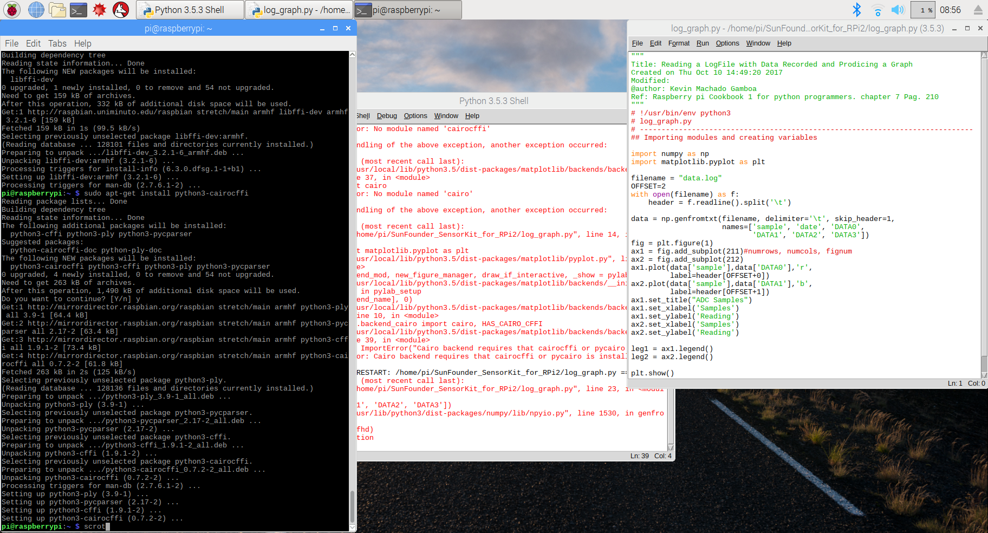

**‘log_graph.py’ Collecting and Writing Data to a LogFile**

As the Book Reference said, this file allow us to get analog data through the 4 pins from the PCF8591 and written into a log file. You can download this document from the github repository (<https://github.com/LatinAmericanProgramer/Python-Analog-to-Digital-Converter-with-PCF8591/blob/master/log_adc.py>). There is not difference between this script and the one that the book guide us to do so to more information about this file please read the reference.

**‘Log_adc.py’ Read the LogFile with the recorded data Recorded & Produce a Graph**

In this script, also I have followed the book guide but to make it work on my version of Raspberry Pi, on Python 3.5.3, we need to make one of the next two changes:

* We need to modify the file “Matplotlibrc”, in the path (/usr/local/lib/python3.5/dist-packages/matplotlib/mpl-data), and replace the backend (normaly with gtk3agg) with “TkAgg” or
* Include in the code ‘import matplotlib’ next to matplotlib.use('TkAgg') as follow:

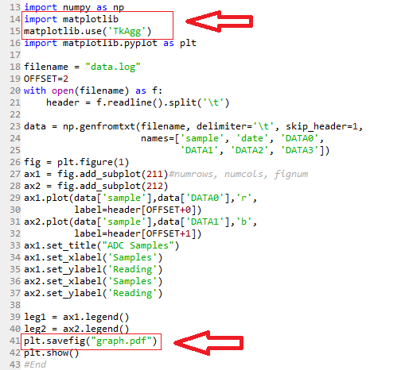

I have also introduced at the line 41 the command savefig(“graph.pdf”) which allow us to have the image saved in PDF format.

To download this script you can used the next link: (<https://github.com/LatinAmericanProgramer/Python-Analog-to-Digital-Converter-with-PCF8591/blob/master/log_graph.py>)